**SOCIETY OF WESTERN ARTISTS**

**Art Workshop REGISTRATION FORM**

**DATES: August 12-13, Saturday/Sunday 9:00 AM – 4:00 PM**

**LOCATION:** SWA Art Center, 527 San Mateo Avenue, San Bruno

**FEES:** $250 SWA Members $275 non-SWA members $252.50 non-SWA members joining SWA

**REGISTRATION DEADLINE:** Thursday, July 13, 2017

**MATERIALS:** A materials list will be sent to you when available.

**CANCELLATIONS**: Cancellations received at least 30 days prior to workshop start date will be refunded in full. Cancellations received less that 30 days prior to workshop start date cannot be refunded unless a substitute student can be found. The Workshop Organizer may have a waiting list for a substitute. In the event SWA cancels the workshop, registration fees will be refunded in full.

**INDEMNITY CLAUSE:** By signing the Registration Form below, I agree to accept full responsibility for any and all injuries, damages, or losses resulting from my voluntary participation in the activities of SWA Art Workshops, and to hold SWA, its licensers, staff, volunteers, and representatives forever harmless from any action, claim, or liability from same.

**WORKSHOP ORGANIZER: Sherry Vockel, sherry@societyofwesternartists.com, (650) 922-7474**

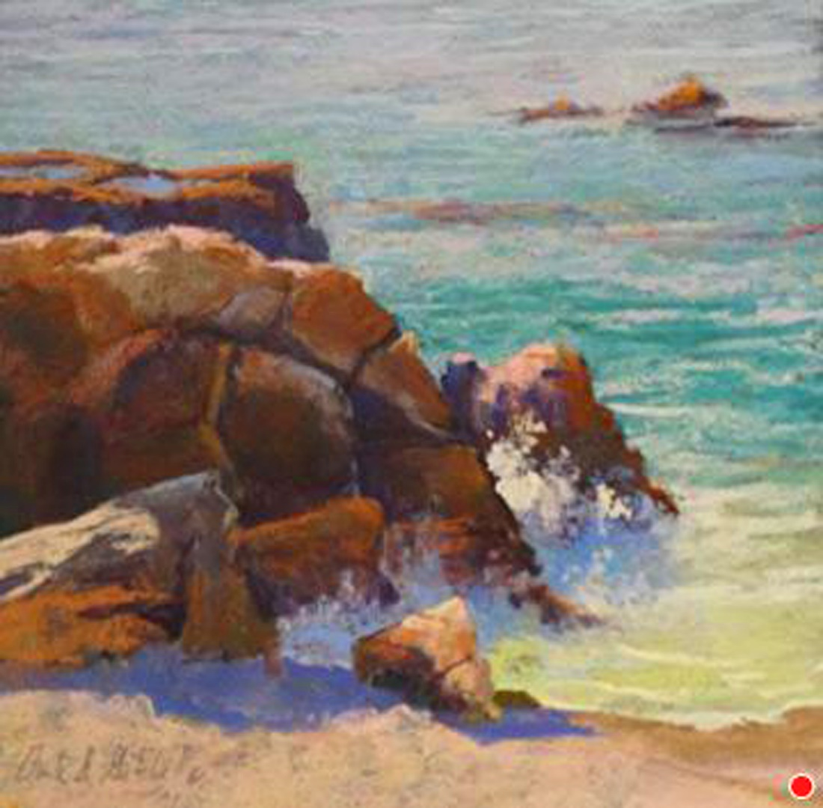

**CLARK MITCHELL, PSWC-DP, PSA**

**2-Day Pastel Landscape Painting**

August 12 – 13. 2017 Beginner – Advanced Students

Learn how to **create strong paintings** through sketching, dynamic underpaintings, **use of rich color**, contrasts in values, temperature & detail. Clark will show you how **to choose an enticing scene** and create a powerful composition. Using photos, Clark will walk you the basics of understanding the elements of a landscape and **infusing your painting with style & emotion. Visit Clark’s website at: https://cgmitchell.com**

**CLARK MITCHELL, PSWC-DP, PSA**

**2-Day Pastel Landscape Painting**

Beginner – Advanced Students

**Cut Here and Return ……………………………………………………………………………………………....Cut Here and Return**

**REGISTRATION FORM**

**CLARK MITCHELL 2 Day PASTEL Landscape Workshop**

August 12 – 13 Saturday-Sunday 9:00 AM – 4:00 PM

Student Name_________________________________Phone _____________________Email_____________________

Address: _______________________________________City ______________________State_______ Zip__________

_____ $250.00 SWA Members only

_____ $75.00 deposit to hold my place in the workshop. **Balance due July 13, 2017**

_____ $275.00 non-SWA Member

_____ $252.50 discount for joining SWA = $22.50 membership credit effective August 12-December 31, 2017

Pay by check made payable to SOCIETY OF WESTERN ARTISTS **or** Credit Card (Visa or Mastercard)

Name on card:_____________________________________ Card #___________________________ Exp. Date _____

Card 3 Digit Code _______ Billing Address _____________________________________________________________

Amount ______________________ Cardholder Signature _________________________________________________

My signature below confirms my understanding and agreement with the above Registration, Indemnity and Cancellation policies:

**Signature ________________________________________________________ Date _______________________**

**Mail Registration Form and Payment to:** SWA, Attn: Sherry Vockel, 527 San Mateo Avenue, San Bruno, CA 94066

**SWA MEMBERSHIP DUES**

January – December $45.00

April – December $33.75 New Members Only

July – December $22.50 New Members Only

October – December $11.25 New Members Only

**JOIN SWA – MEMBERSHIP BENEFITS**

* 5-6 juried art exhibitions per year including our prestigious

**Annual Exhibition of Art** with over $5000 prizes

* 9 artist lecture/demonstrations yearly
* Bi-monthly newsletter – ads for your classes/workshops (fee)
* Link to your website or social media
* Signature Award Program
* Discount on Artist Workshops
* Rent the Art Center for solo/group art shows