**SOCIETY OF WESTERN ARTISTS**

**Art Workshop REGISTRATION FORM**

**DATES: April 29 - 30, Saturday/Sunday 9:00 AM – 4:00 PM**

**LOCATION:** SWA Art Center, 527 San Mateo Avenue, San Bruno

**FEES:** $100 SWA Members $150 non-SWA members $133.75 non-SWA members joining SWA

**REGISTRATION DEADLINE:** Saturday April 15, 2017

**MATERIALS:** A materials list will be sent to you when available.

**CANCELLATIONS**: Cancellations received at least 30 days prior to workshop start date will be refunded in full. Cancellations received less that 30 days prior to workshop start date cannot be refunded unless a substitute student can be found. The Workshop Organizer may have a waiting list for a substitute. In the event SWA cancels the workshop, registration fees will be refunded in full.

**INDEMNITY CLAUSE:** By signing the Registration Form below, I agree to accept full responsibility for any and all injuries, damages, or losses resulting from my voluntary participation in the activities of SWA Art Workshops, and to hold SWA, its licensers, staff, volunteers, and representatives forever harmless from any action, claim, or liability from same.

**WORKSHOP ORGANIZER: Sherry Vockel, sherry@societyofwesternartists.com, (650) 922-7474**

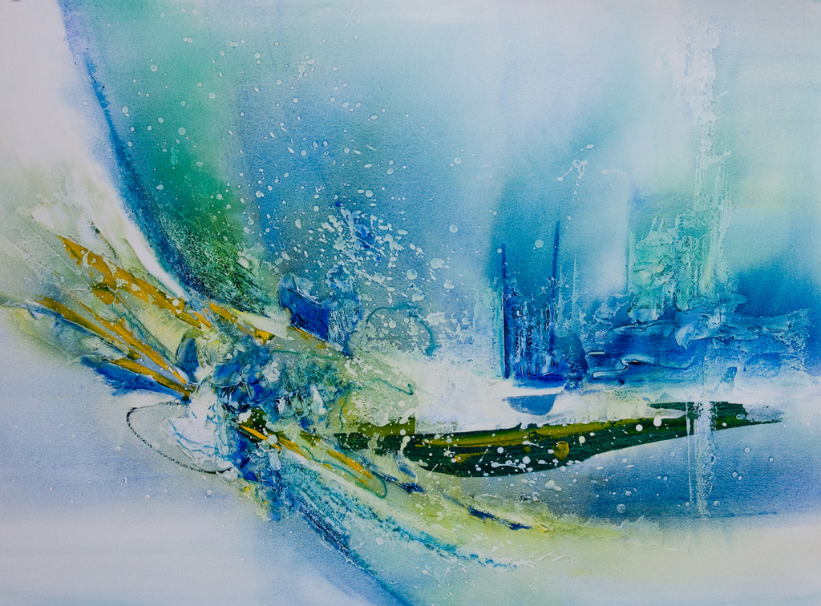

**RON ANDREWS, ISEA, WASH-H**

**2-Day Abstracted Contemporary Landscape – Water Media**

April 29 – 30, 2017 Sat/Sun Intermediate – Advanced Students

Learn to create abstract paintings using watermedia on paper. Using a multistep/multilayer technique, this style will emphasize spontaneity and painterly techniques. Composition, shapes, values, color, texture and other design elements will be taught. Water Media will include watercolor, acrylic gesso and gouache. **Visit Ron’s website at: ronsartgallery.com**

**CLARK MITCHELL, PSWC-DP, PSA**

**2-Day Pastel Landscape Painting**

Beginner – Advanced Students

**Cut Here and Return ……………………………………………………………………………………………....Cut Here and Return**

**REGISTRATION FORM**

**RON ANDREWS 2 Day Abstracted Contemporary Landscape Workshop**

April 29-30 Saturday-Sunday 9:00 AM – 4:00 PM

Student Name_________________________________Phone _____________________Email_____________________

Address: _______________________________________City ______________________State_______ Zip__________

_____ $100.00 SWA Members only

_____ $50.00 deposit to hold my place in the workshop. **Balance due April 15, 2017**

_____ $150.00 non-SWA Member

_____ $133.75 discount for joining SWA = $33.75 membership credit effective April 29 - December 31, 2017

Pay by check made payable to SOCIETY OF WESTERN ARTISTS **or** Credit Card (Visa or Mastercard)

Name on card:_____________________________________ Card #___________________________ Exp. Date _____

Card 3 Digit Code _______ Billing Address _____________________________________________________________

Amount ______________________ Cardholder Signature _________________________________________________

My signature below confirms my understanding and agreement with the above Registration, Indemnity and Cancellation policies:

**Signature ________________________________________________________ Date _______________________**

**Mail Registration Form and Payment to:** SWA, Attn: Sherry Vockel, 527 San Mateo Avenue, San Bruno, CA 94066

**SWA MEMBERSHIP DUES**

January – December $45.00

April – December $33.75 New Members Only

July – December $22.50 New Members Only

October – December $11.25 New Members Only

**JOIN SWA – MEMBERSHIP BENEFITS**

* 5-6 juried art exhibitions per year including our prestigious

**Annual Exhibition of Art** with over $5000 prizes

* 9 artist lecture/demonstrations yearly
* Bi-monthly newsletter – ads for your classes/workshops (fee)
* Link to your website or social media
* Signature Award Program
* Discount on Artist Workshops
* Rent the Art Center for solo/group art shows